

|  |  |  |  |  |  |  |  |  |
| --- | --- | --- | --- | --- | --- | --- | --- | --- |
|  | | | | | | | | |
|  | | **Team 6 - iHome** | | | | |  | |
|  |  | | | | | | |  |
|  | | | | **Liang Mengfei**  **Lam Weng Cong**  **Zhang Yuting**  **Vanessa Lim Yurong** |  | | | |
|  | | | | **Date**  22 February 2021  **Course Title**  Graduate Certificate in Architecting Scalable Systems |  | | | |
|  | | |  | | |  | | |

Table of Contents

Project Members 3

Project Overview 3

General Architecture 3

Scope of Work 4

Business Model 4

Effort Estimates 5

# Project Members

|  |  |
| --- | --- |
| Name | Email Address |
| Liang Mengfei | mengfei.liang@ncs.com.sg |
| Lam Weng Cong | wengcong.lam@ncs.com.sg |
| Zhang Yuting | yuting.zhang@ncs.com.sg |
| Vanessa Lim Yurong | vanessa.lim1@ncs.com.sg |

# Project Overview

A platform that provides professional servicing for homeowners.

Services range from locksmith work, servicing/maintenance of all facilities and equipment and to general cleaning.

# General Architecture

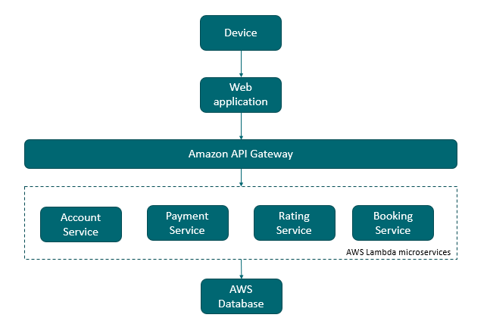

# Scope of Work

## Business Model

|  |  |
| --- | --- |
| Component | Description |
| Seed | Platform that providing home services |
| Producers | Professional/Technicians |
| Consumers | Homeowners |
| Interactions | * Account creation * Booking service * Pay for service * Recommendation function based on user requirements such as budgets, location, vendor rating etc… * Customer rating service * Promote code function |
| Magnet | Producer:   * Incentive based on customer rating   Consumer:   * Promote code recognition * Referral scheme |
| Toolbox | * API * Integrate with payment system * Web application * AWS EC2 |
| Matchmaker | Algorithms  Accurate matching  Curate content |
| Scaling Platform Business | Platform would be scalable in terms of functionality as each function is developed as a microservice. |
| Platform Ecosystem | Platform is also scalable in terms of cloud usage arising from changing demand. |

# Effort Estimates

Work Breakdown Structure as follows.

|  |  |  |  |
| --- | --- | --- | --- |
| Task # | Sub-Task No. | Task Name | Duration |
| **1 - Design** | | | |
|  | 1.1 | System design | 2 days |
| **2 – Development Environment Set-up** | | | |
|  | 2.1 | Development environment set-up  - IDE  - Database  - Project Wiki  - Git | 1 day |
| **3 – Cloud Environment Set-up** | | | |
|  | 3.1 | AWS EC2 | 4 day |
| **4 – Service – Account creation** | | | |
|  | 4.1 | Create user account | 1 day |
|  | 4.2 | Update user info | 1 day |
|  | 4.3 | View user info | 1 day |
| **5 – Service – Booking service** | | | |
|  | 5.1 | Search service page | 1 day |
|  | 5.2 | Recommendation logic | 3 days |
|  | 5.3 | Display search result page | 1 day |
|  | 5.4 | Display page for individual service vendor | 1day |
|  | 5.5 | Add service to cart | 3 days |
|  | 5.6 | View cart | 1 day |
|  | 5.7 | View booking summary | 1 day |
| **6 – Service – Payment service** | | | |
|  | 6.1 | Apply promote code | 1 day |
|  | 6.2 | Link to payment service provider | 5 days |
|  | 6.3 | View invoice | 1 day |
| **7 – Service – Customer rating service** | | | |
|  | 7.1 | Customer rating page | 1 day |
| **8 – System testing** | | | |
|  | 8.1 | Testing | 5 days |
| **9 – Documentation** | | | |
|  | 9.1 | Project Report | 5 days |
|  | 9.2 | Progress Report | 1 day |
| **Total man days** | | | 40 days |